5th November 2018

**YOKOHAMA Tyres Coming Factory-Equipped on German Premium Car Maker’s Midsize Sports Activity Vehicle**

YOKOHAMA began supplying its “ADVAN Sport V105” to Germany’s BMW Group for use as original equipment (OE) on the M Performance version of the automaker’s X3 in April 2018. The X3 M Performance model comes equipped with 245/45R20 103Y size front tyres and 275/40R20 106Y rear tyres. The X3 M Performance model was launched in markets around the world in September 2018.   
  
The “ADVAN Sport V105” is a high-performance tyre developed by YOKOHAMA primarily for use on high-power premium automobiles. The tyre delivers excellent driving performance combined with superior comfort and safety. The tyres being supplied for the new X3 M Performance model were jointly developed with BMW and bear the German automaker’s star mark symbol of approval on the tyre sidewall.  
  
Under its three-year medium-term management plan, GD2020, launched in February 2018, YOKOHAMA has positioned the expansion of its presence in the premium tyre markets as the core goal for its consumer tyre business. One of the specific strategies for achieving that goal is the “premium-car tyre strategy”, which aims to increase use of YOKOHAMA tyres as OE on premium cars in Japan and abroad by making YOKOHAMA the tyre maker chosen by automakers around the world in recognition of its technologies and quality.

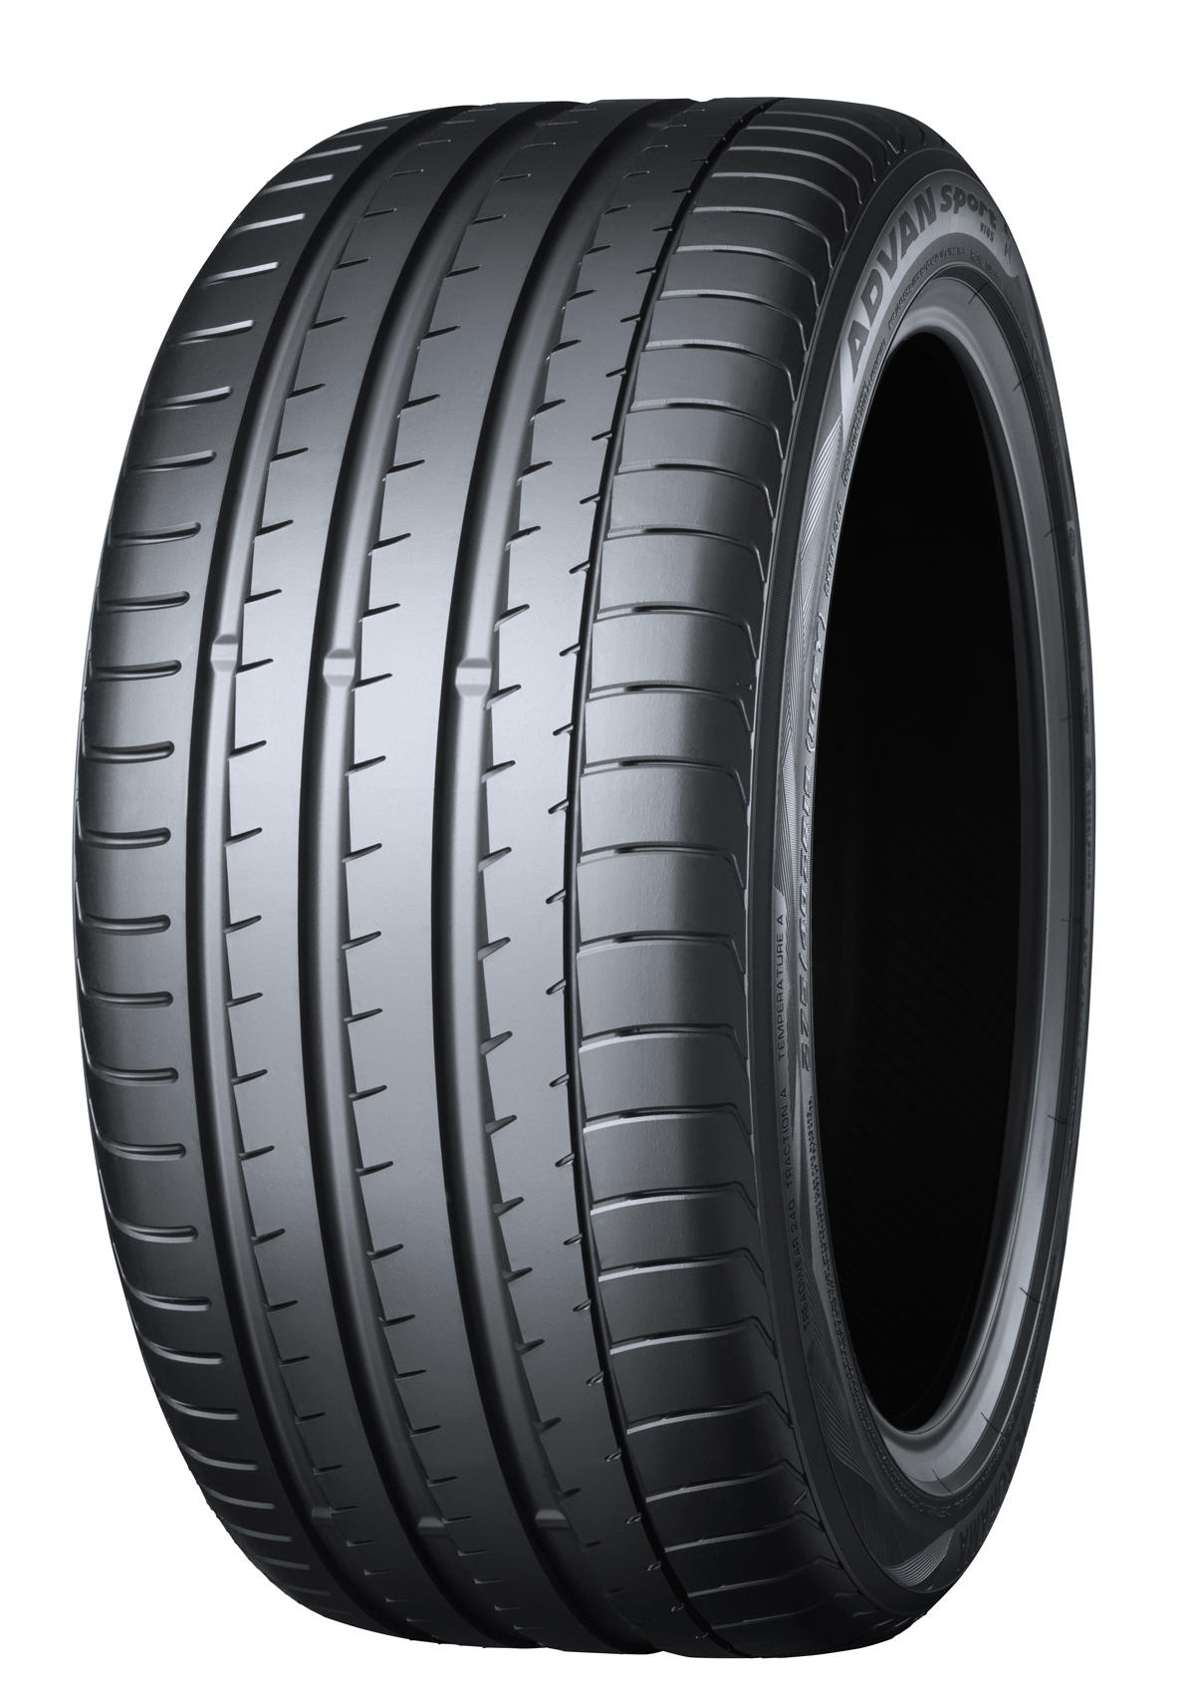

*The “ADVAN Sport V105”; tyre shown in photo differs in size from those installed on the X3 M Performance model*